**CTF Challenge: Data Privacy Laws and Regulations**

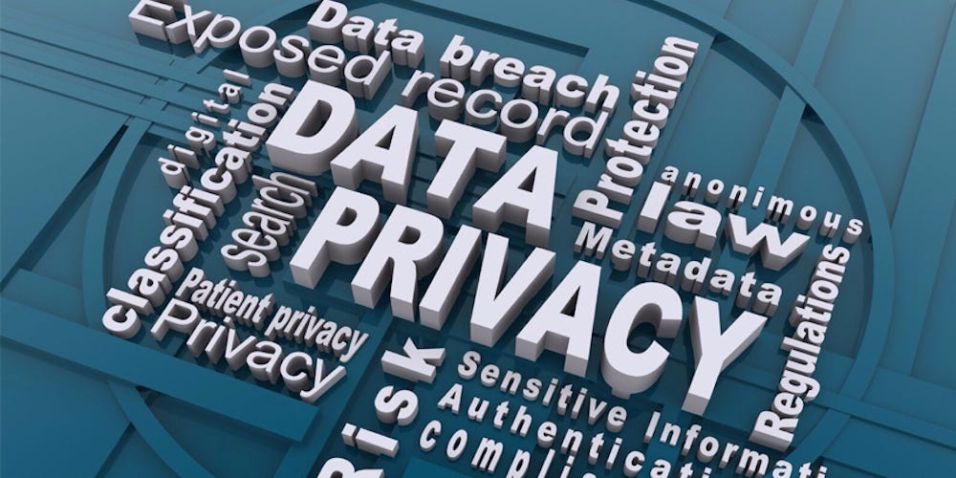

**Data Privacy Laws and Regulations?**

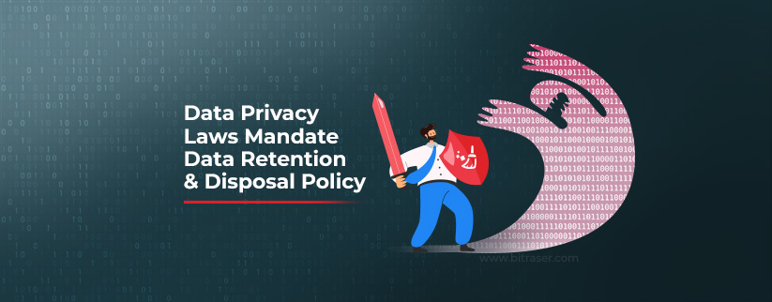

Data privacy laws and regulations are legal frameworks that govern how organizations collect, use, store, and share personal data. These laws aim to protect individuals' privacy rights and ensure that their personal information is handled responsibly by organizations. Here's an overview of some prominent data privacy laws and regulations:



1. **General Data Protection Regulation (GDPR)**: Enforced in the European Union (EU) and European Economic Area (EEA), GDPR sets out rules for the processing of personal data of individuals within the EU/EEA. It emphasizes transparency, consent, data minimization, and individuals' rights over their data, such as the right to access, rectification, and erasure (right to be forgotten).
2. **California Consumer Privacy Act (CCPA)**: Implemented in California, CCPA grants California residents certain rights regarding their personal information held by businesses. It requires businesses to disclose data collection practices, provide opt-out options for sale of personal information, and maintain reasonable security measures.
3. **Health Insurance Portability and Accountability Act (HIPAA)**: In the United States, HIPAA regulates the use and disclosure of protected health information (PHI) by healthcare providers, health plans, and their business associates. It includes security standards to protect PHI and privacy rules that govern its use.
4. **Personal Data Protection Act (PDPA)**: Implemented in Singapore, PDPA governs the collection, use, and disclosure of personal data by organizations. It includes provisions for obtaining consent, data accuracy, protection against unauthorized access, and individuals' rights to access and correct their data.
5. **Personal Information Protection and Electronic Documents Act (PIPEDA)**: In Canada, PIPEDA applies to the private sector and sets rules for how organizations collect, use, and disclose personal information in the course of commercial activities. It includes principles of consent, accountability, and individuals' rights regarding their data.
6. **Children's Online Privacy Protection Act (COPPA)**: In the United States, COPPA regulates the collection of personal information online from children under the age of 13. It requires parental consent for collecting data from children and imposes restrictions on data retention and security practices.
7. **Data Protection Directive 2016/680 (Law Enforcement Directive)**: Enforced in the EU, this directive sets out rules for the processing of personal data by law enforcement authorities for criminal law enforcement purposes. It aims to ensure a balance between law enforcement needs and individuals' privacy rights.
8. **Privacy Act of 1974**: In the United States, this law establishes rules for federal agencies regarding the collection, use, and disclosure of personal information maintained in systems of records. It grants individuals access to their records and allows them to request corrections.

# **Capture the Flag (CTF) Challenges**

**Flag 1. Which regulation governs personal data processing in the European Union?**

Answer: GDPR

**Flag 2. Which law grants California residents rights over their personal information?**

Answer: CCPA

**Flag 3. What US law regulates the use of protected health information (PHI)?**

Answer: HIPAA

**Flag 4. Which Singaporean act governs the collection and use of personal data?**

Answer: PDPA

**Flag 5. Which directive sets rules for processing personal data by EU law enforcement?**

Answer: Law Enforcement Directive